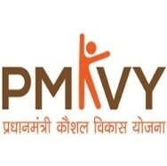
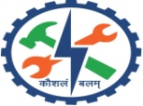
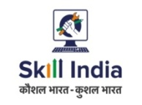
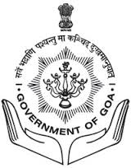

GOVERNMENT OF OA
DIRECTORATE OF SKILL DEVELOPMENT AND ENTREPRENEURSHIP
Shram Shakti Bhavan, 3rd Floor, Patto Plaza, Panaji, Goa - 403001.
Ph.No. : (0832) 2437059, Fax : 2437060
Website: www.dsde.goa.gov.in Email: dir-sdct.goa@nic.in

ATTENTION: Launch of “Customised Crash Course Programme
for COVID Warriors” in Healthcare Courses under PMKVY

The Directorate of Skill Development & Entrepreneurship, Govt of Goa in collaboration with National Skill Development Corporation (NSDC), District Skill Committees (DSCs) and Directorate of Health Services is conducting crash Skilling Courses under Pradhan Mantri Kaushal Vikas Yojana (PMKVY 3.0), the flagship skill development Scheme fully funded by Ministry of Skill Development & Entrepreneurship (MSDE), Govt of India.
The objective of the skilling program is to support the fight against the ongoing pandemic. The Proposed Courses are as under:-
Sr. No. | Course | Entry Qualification
1 | General Duty Assistant (GDA) | 10th Pass
2 | Home Health Aide (HHA) | 10th Pass
3 | GDA Advanced – Critical Care | 10th Pass
4 | Emergency Medical Technician- Basic | 12th Pass
5 | Medical Equipment Technology Assistant | 10th Class + I.T.I with 3-5 Years of experience OR Diploma (technical subjects like electronic / mechanical / electrical/ computers / any other related ﬁeld)
Mode of training: The candidates to undergo crash course for 21 days in Training Institutes affiliated to NSDC and On Job Training (OJT) of three months in PHCs/CHCs and other recognized Hospitals.

Age of the candidates: 18 - 45 years

IMPORTANT NOTE: The training under these courses commences immediately from 18th June 2021 onwards. To know more, the aspiring candidates are requested to contact Directorate of Skill Development, Shram Shakti Bhavan, Patto Panaji on emails dir-sdct.goa@nic.in, ssdm-pmkvy.goa@gov.in or visit nearest Government ITI for support for registration and further undergoing the course as well as contact following Govt ITIs on following numbers:-
Sr.No. | Name of ITI | Email id | Contact No.
1 | Farmagudi | farmagudi-iti.goa@nic.in | 2980070 / 9422062929
2 | Margao | margao-iti.goa@nic.in | 2714887 / 9923312964
3 | Cacora | cacora-iti.goa@nic.in | 2650270 / 992331294/8329570729
4 | Vasco | vasco-iti.goa@nic.in | 2524030 / 9822138737
5 | Canacona | canacona-iti.goa@nic.in | 2633354 / 9158377932
6 | Panaji | panaji-iti.goa@nic.in | 2226333 / 9422061232
7 | Mapusa | mapusa-iti.goa@nic.in | 2262637 /9403175964
8 | Pernem | pernem-iti.goa@nic.in | 2201238 / 9923144341
9 | Bicholim | bicholim-iti.goa@nic.in | 2362315 / 9923693684
10 | Sattari | sattari-iti.goa@nic.in | 2370242 / 9637084864
11 | PMKVY Training Centre | -- | 80077 08780/97640 15152
To know more on PMKVY scheme, please visit website https://pmkvyofficial.org
-Sd-
Director(SD&E)

